**GROOVY**

**Basic syntax in groovy**

* **In groovy, it is not necessary to put a semicolon at the end of the statement like in java.**

**Groovy Script to print the basic script.**

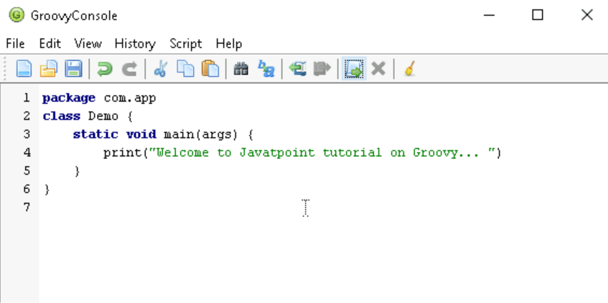

**Output:**

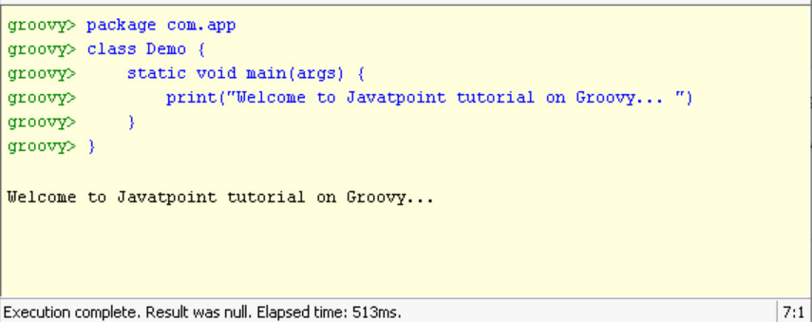

* **In groovy, we can print a line without using round brackets**

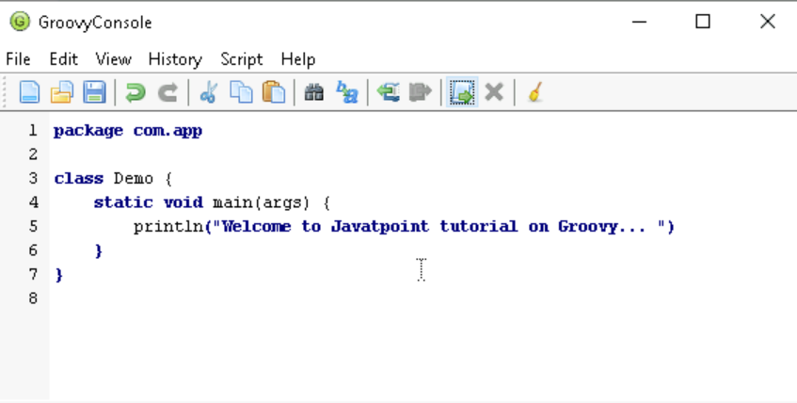

**Output:**

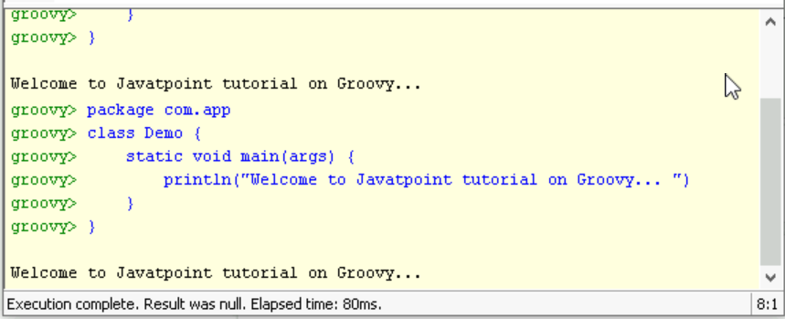

* **In groovy, double quotes as well as single quotes can be used in a string.**

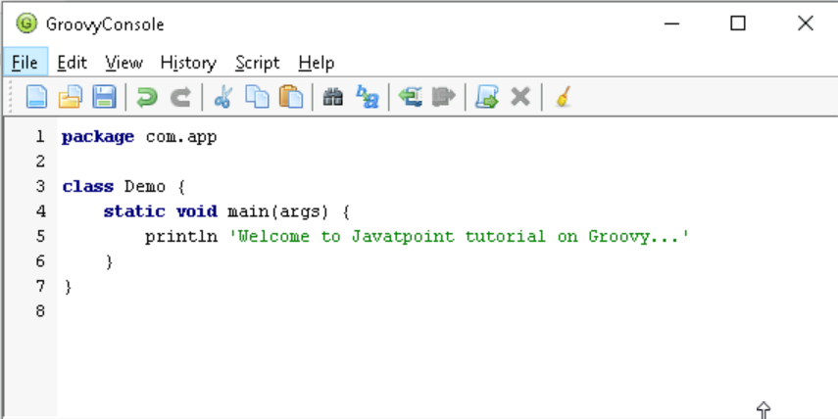

**Output:**

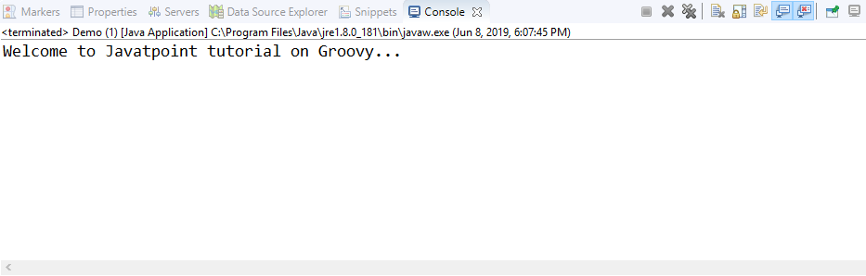

**We can have a single line comment as well as a multi-line comment just like in java.**

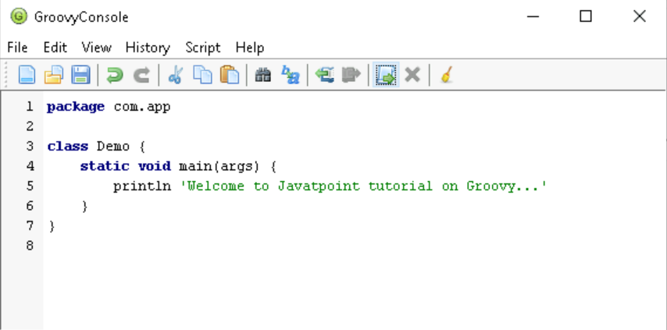

**Output:**

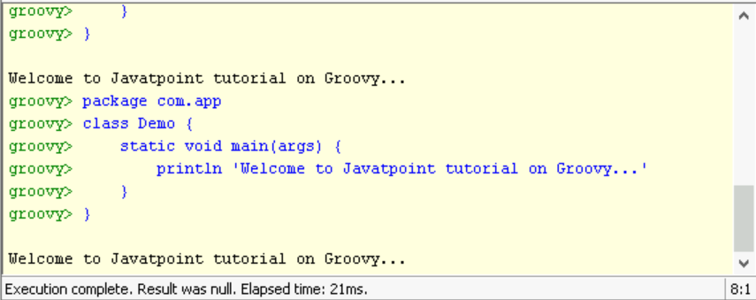

**Arithmetic operator**

**Arithmetic operators are the basic mathematical operators, which are used to perform addition, subtraction, multiplication, division, Remainder and Power.**

**Example 1:**

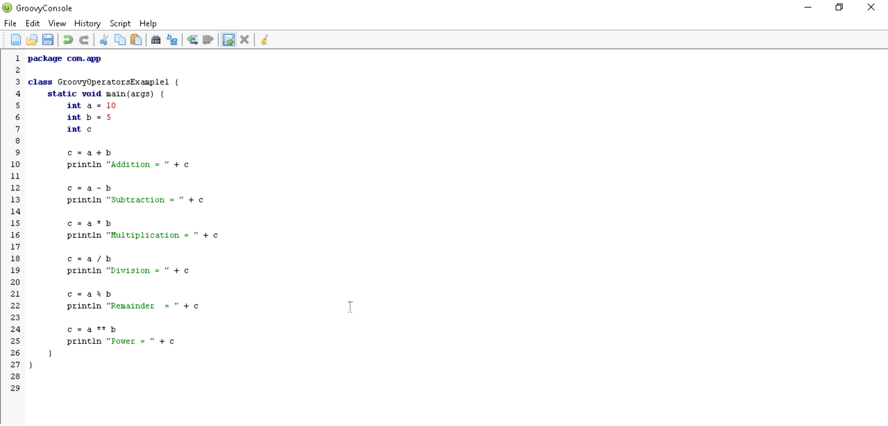

**Output:**

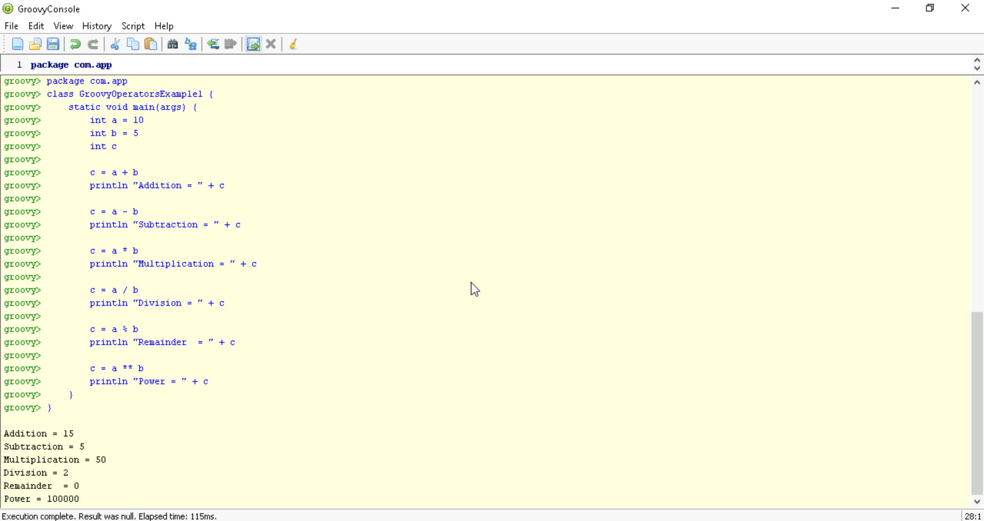

**In groovy, we also have some functions which are used to perform Arithmetic operations like plus, minus, intdiv and power. The use of these functions are shown in the example which is given below.**

**Example 2:**

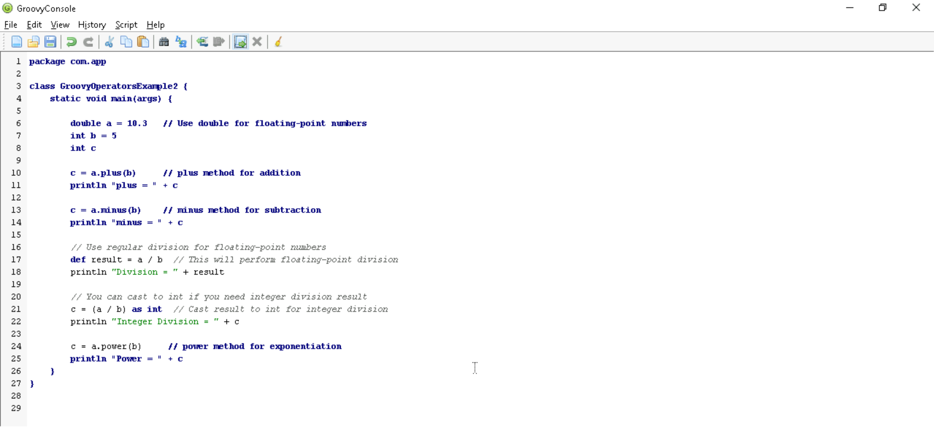

**Output:**

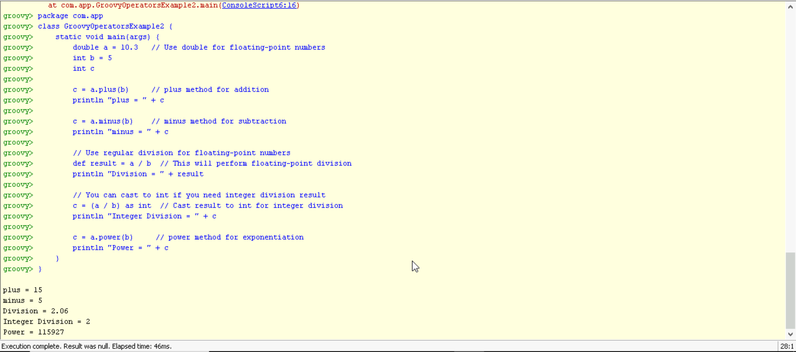

**Unary operators**

**In groovy, Unary operators require only one operator to perform the operation. Unary operators are used to perform the operations such as increment/decrement, negating, and inverting the values of a Boolean.**

**Example 3:**

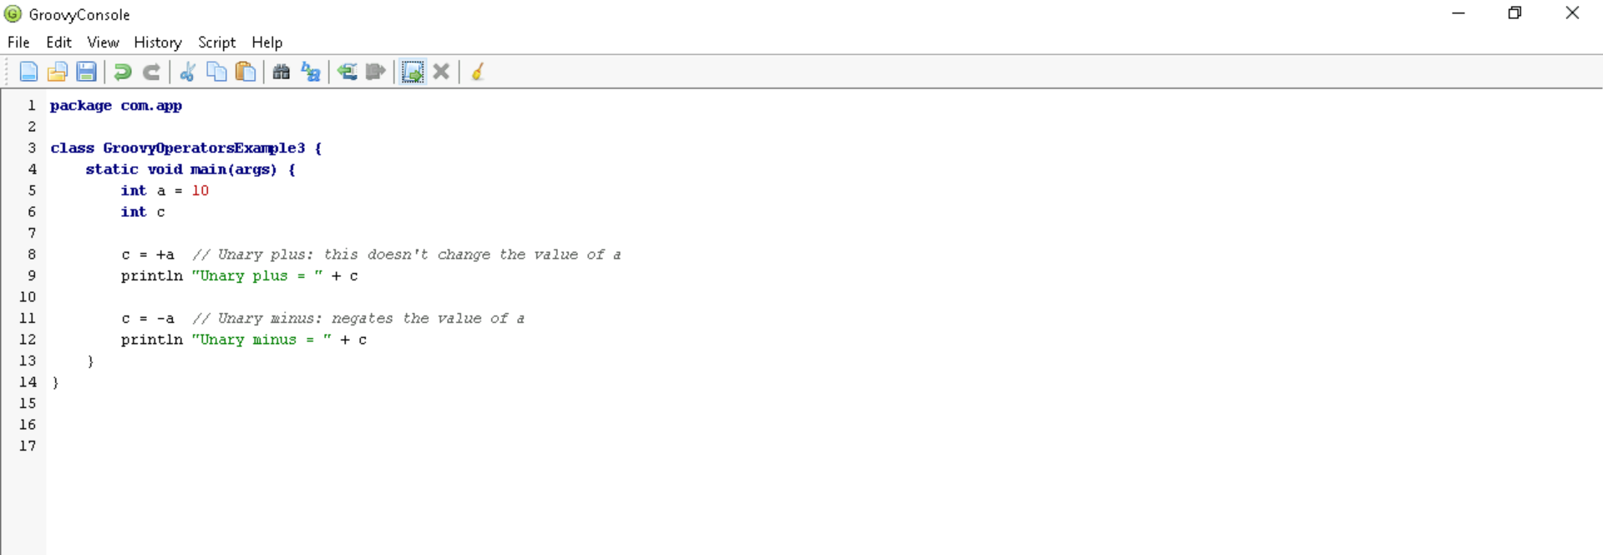

**Output:**

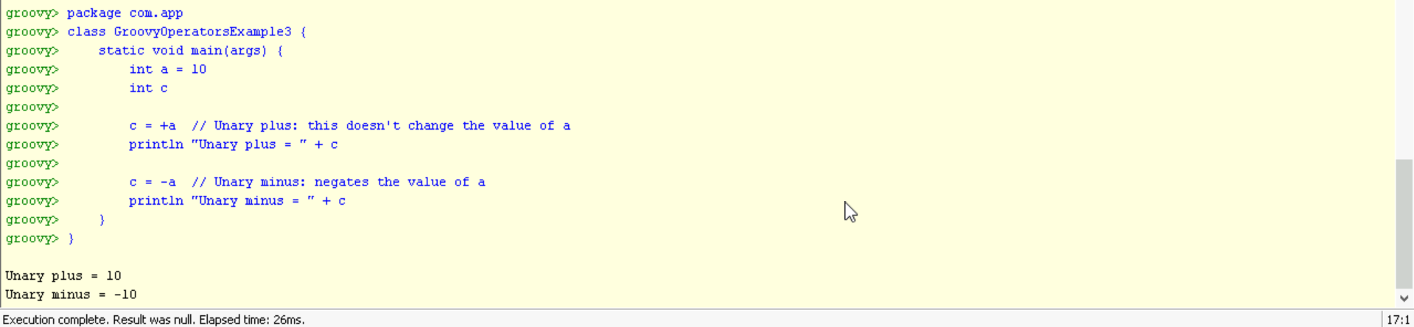

**Example 4:**

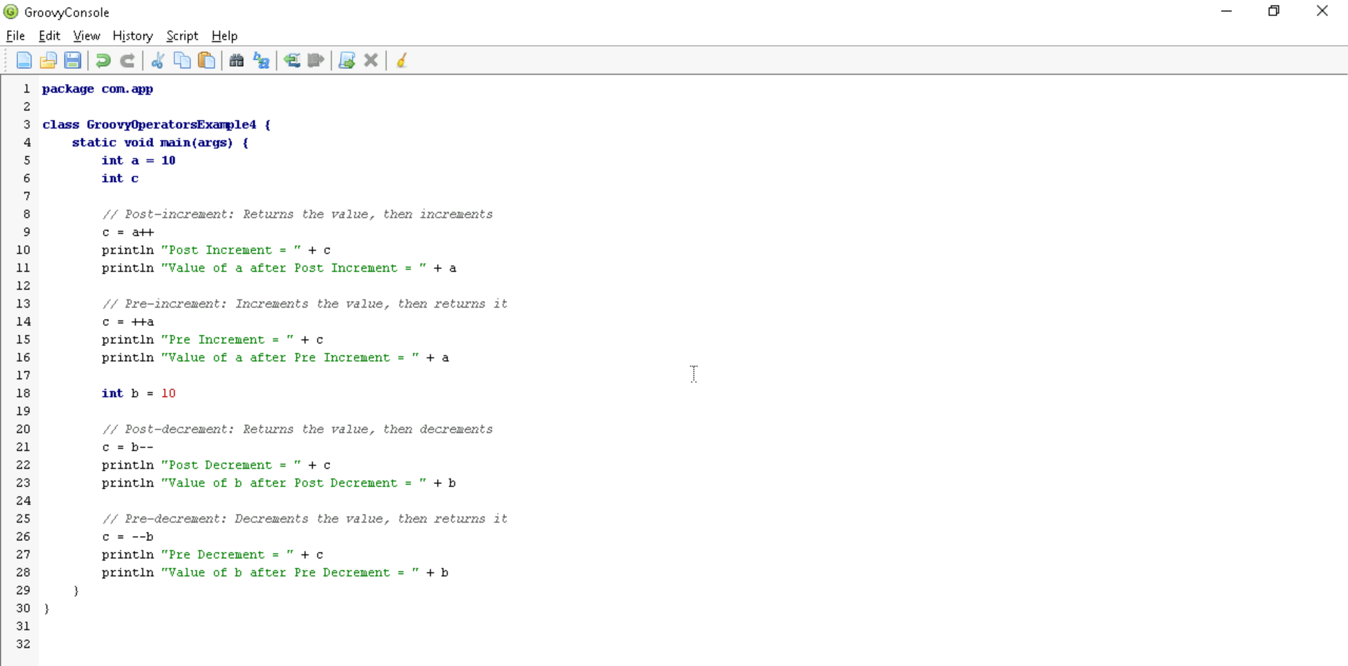

**Output:**

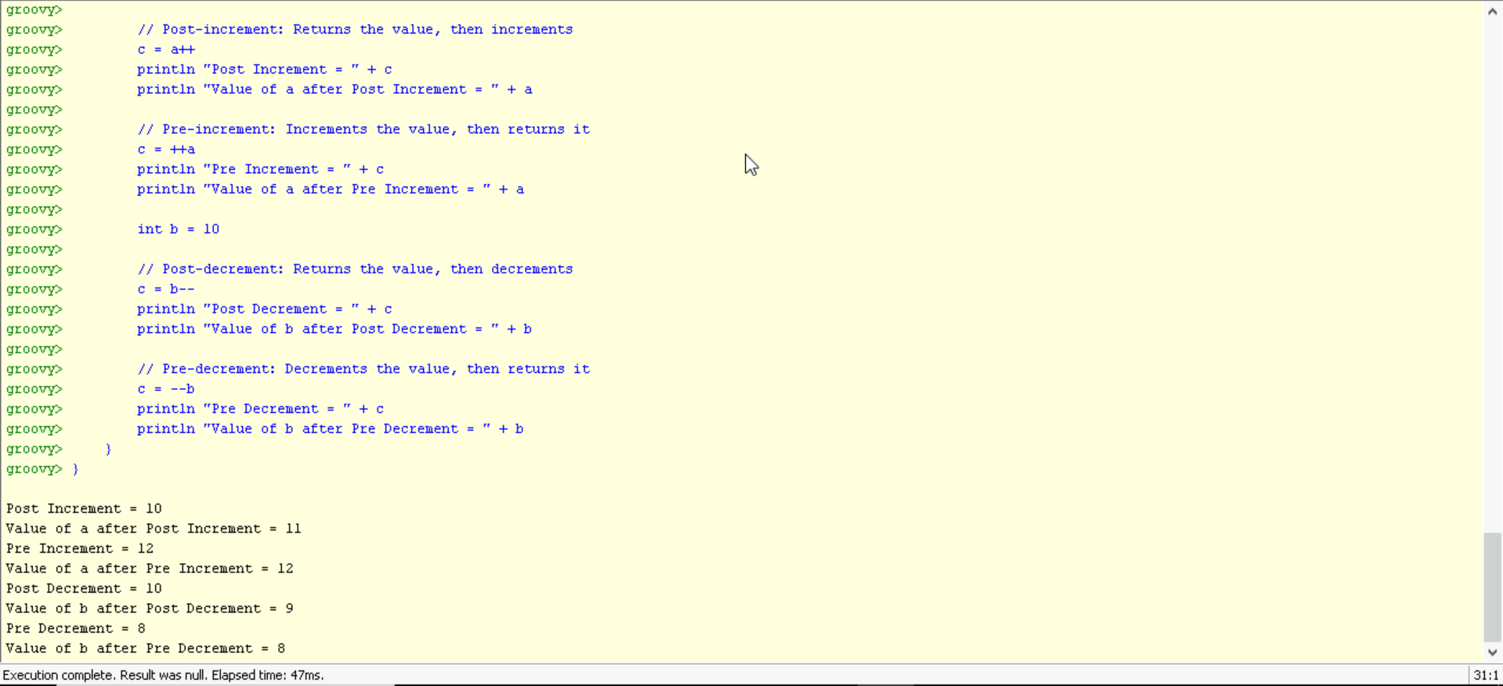

**Assignment arithmetic operators**

**In groovy, assignment arithmetic operators are used to assign a new value to the variable.**

**Example 5:**

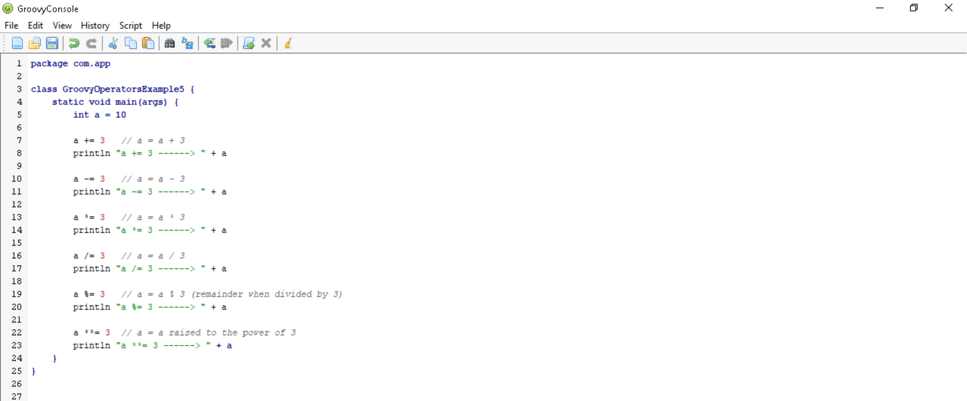

**Output:**

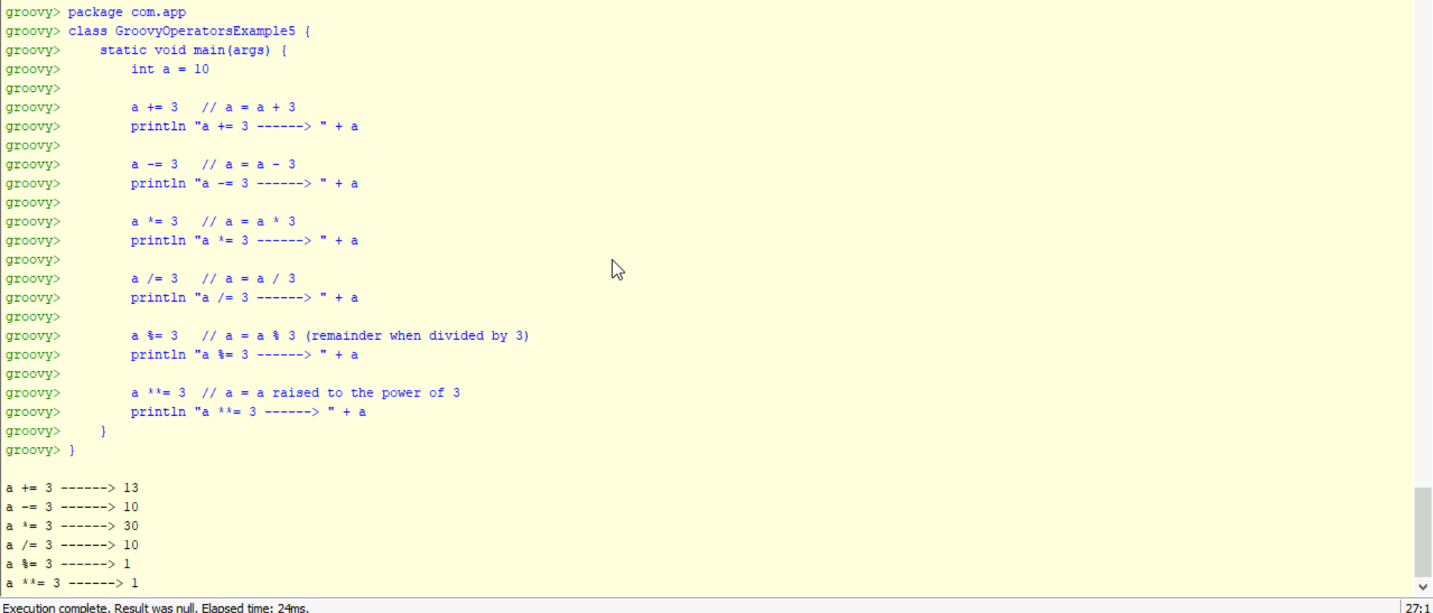

Relational operators

In groovy, relational operators are used to compare two objects to check wether they are same or different or one is greater than, less than or equal to other object.

Example 6:

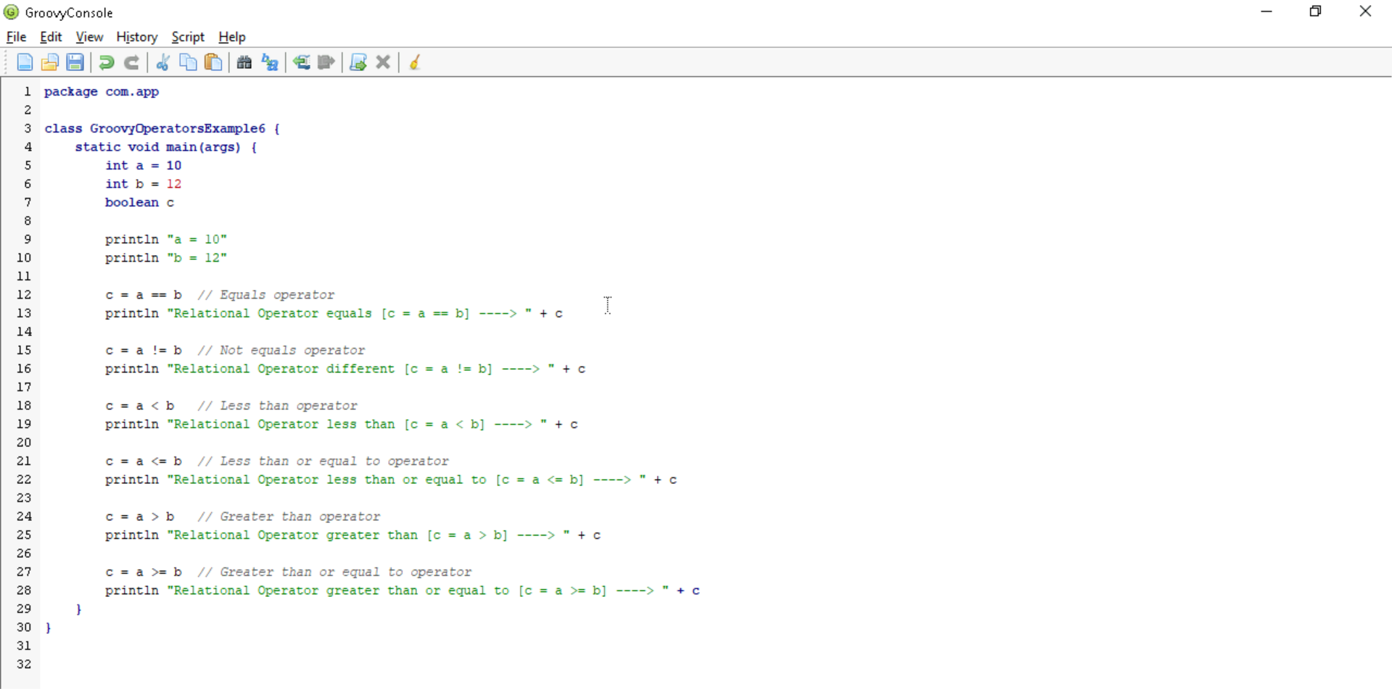

Output:

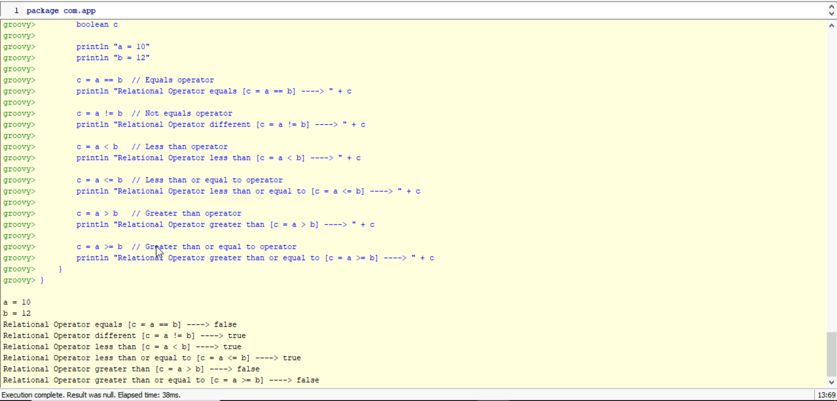

Logical operators

In groovy, there are 3 logical operators for Boolean expression, and these operators are AND(&&), OR(||) and NOT(!)

Example 7:

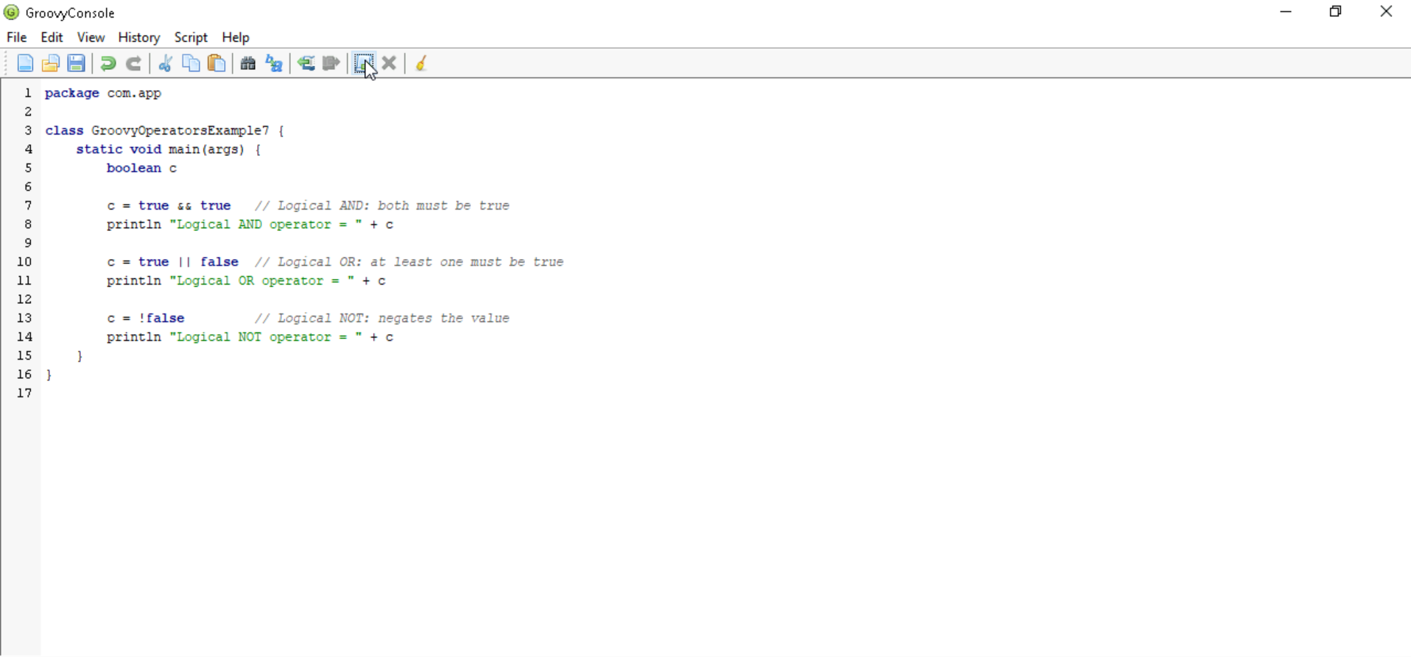

Output:

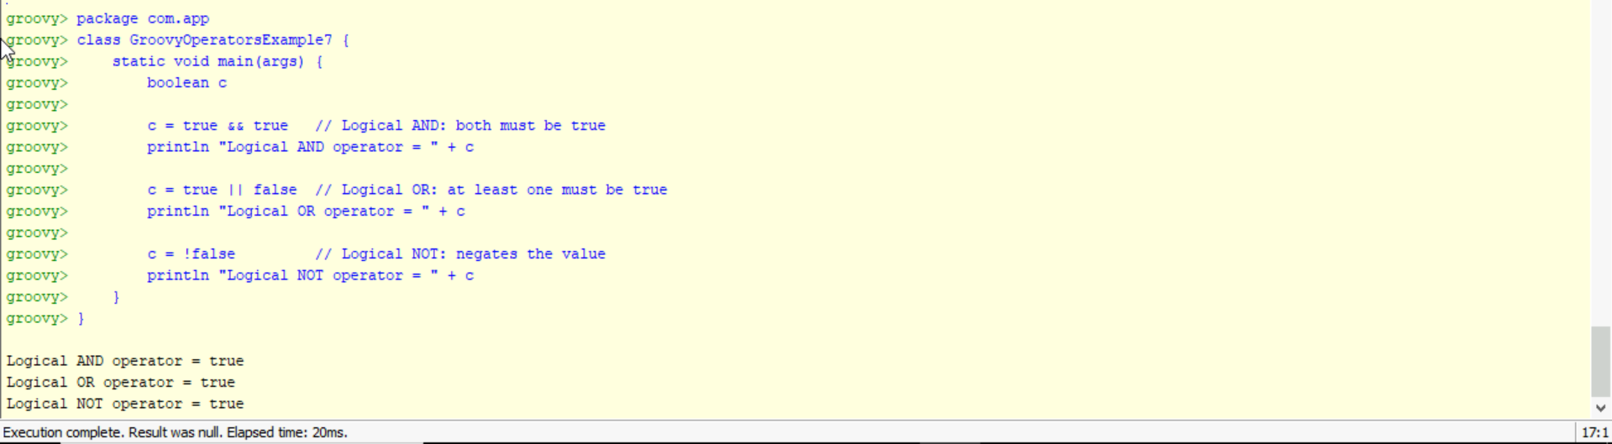

Example 8:

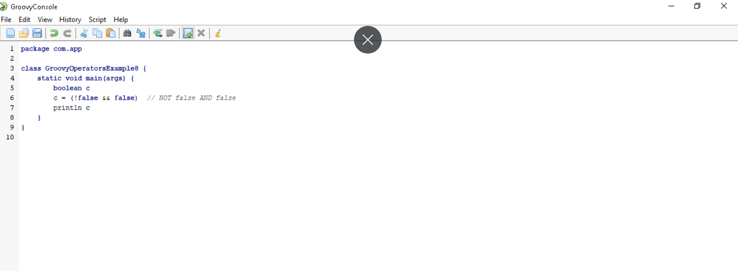

Output:

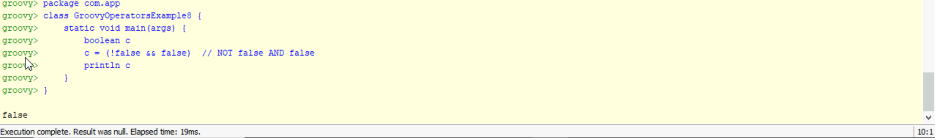

Example 9:

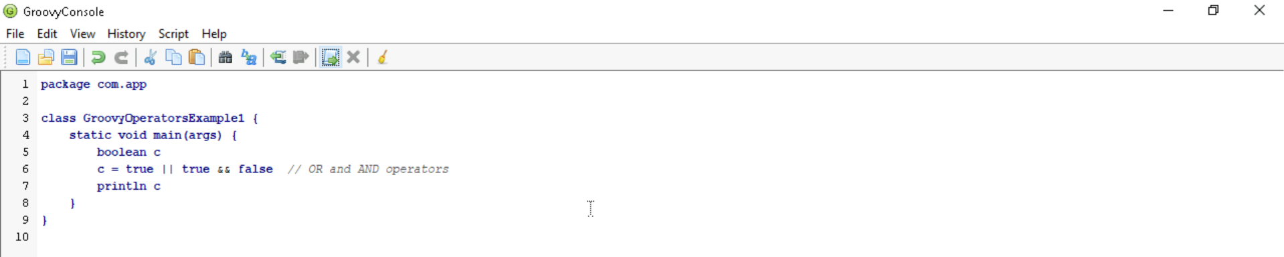

Output:

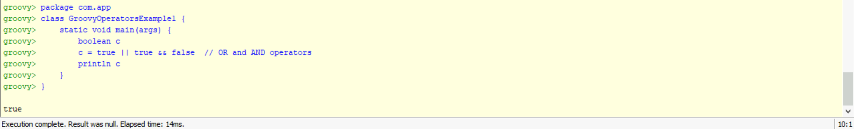

Bitwise operators

In groovy, Bitwise operators are used for operating on binary digits or bits of an integer.

Example 10:

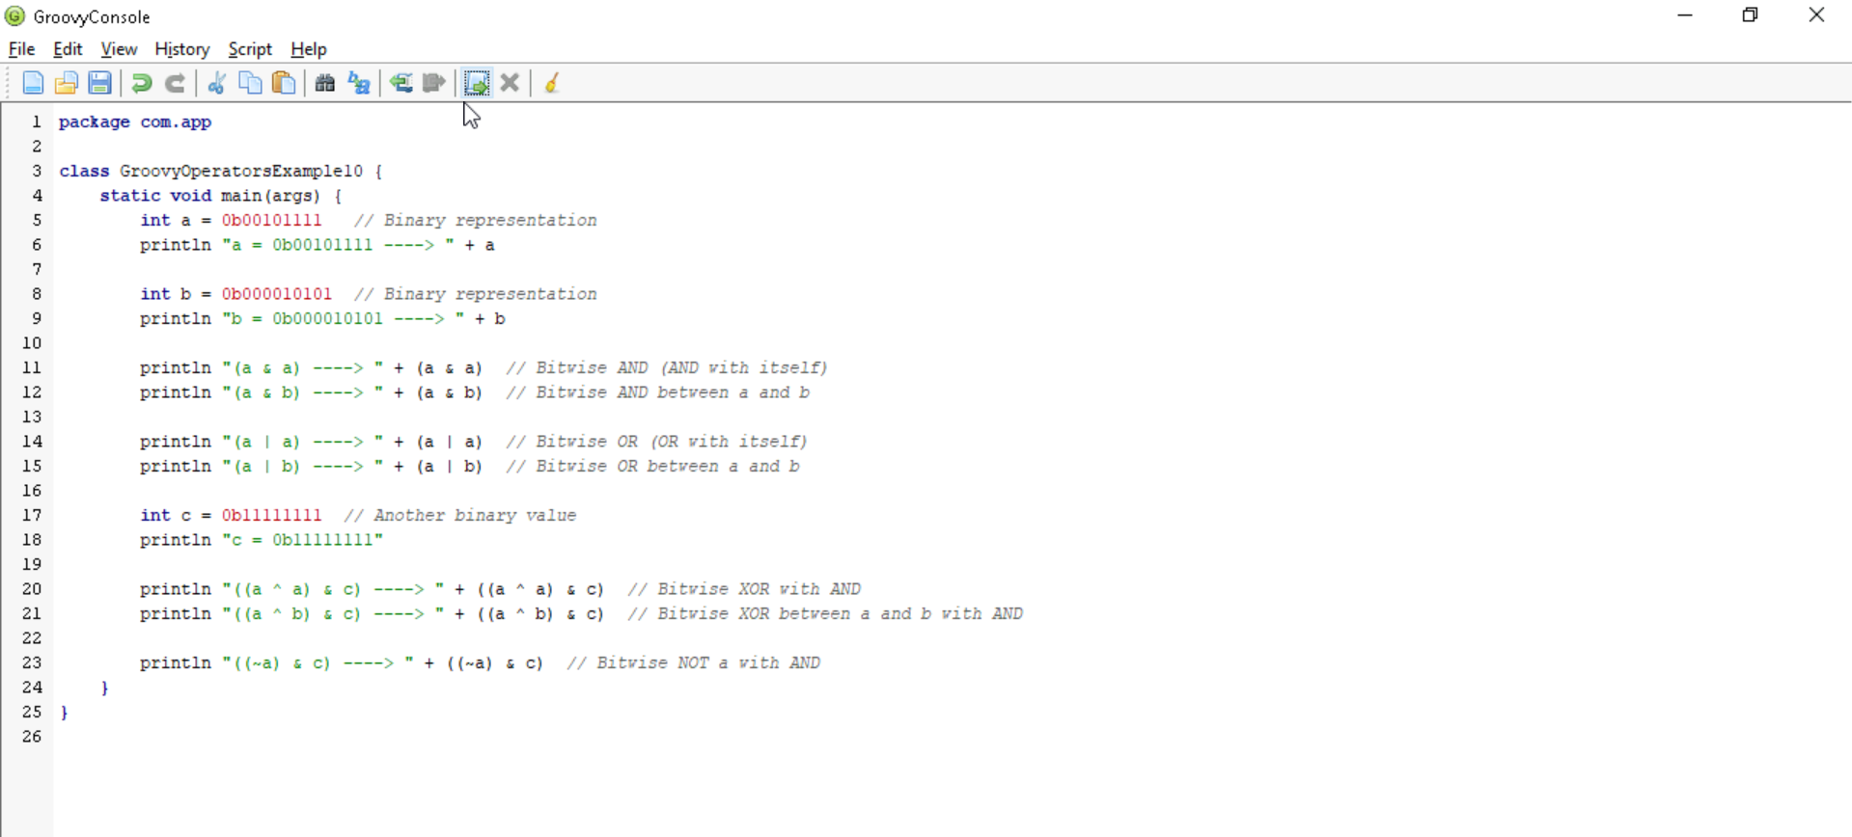

Output:

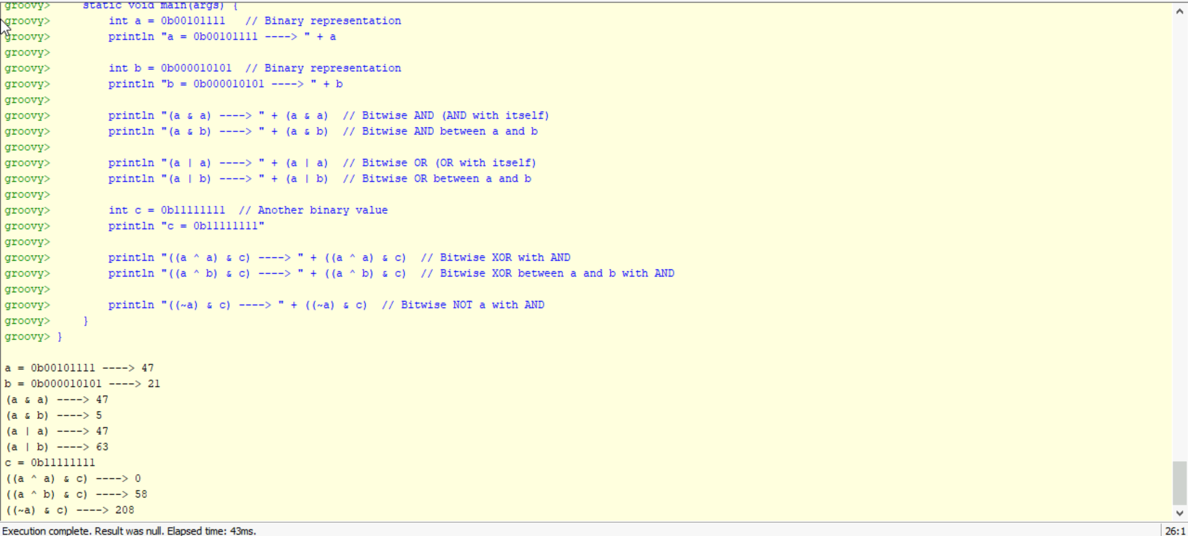

Example 11:

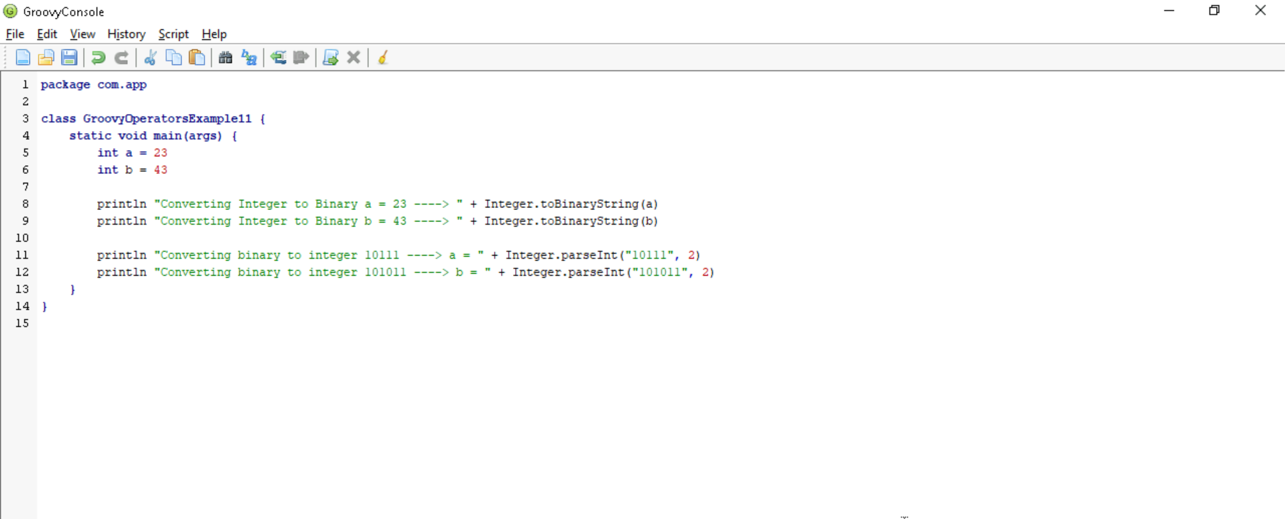

Output:

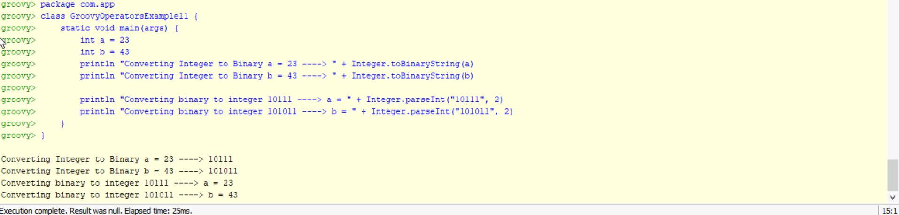

Conditional operators

In groovy, there are three types of conditional operators they are as follow:

* **Not operator**

In groovy, "not" operator is used invert the result of the Boolean expression.

Example 12:

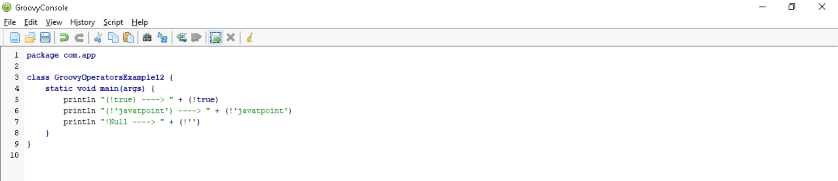

Output:

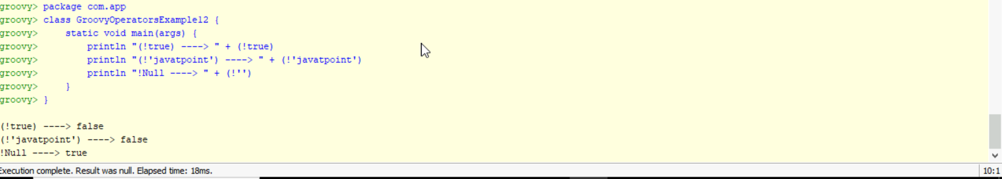

Example 13:

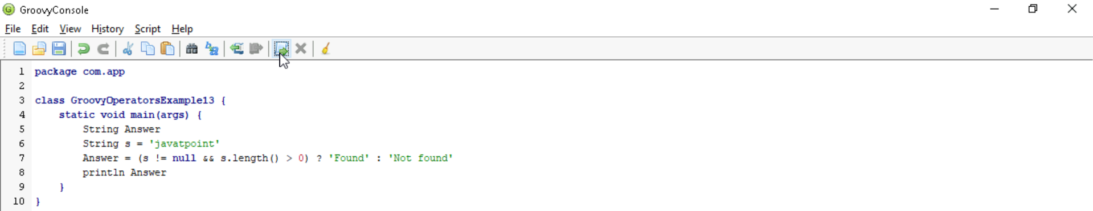

Output:

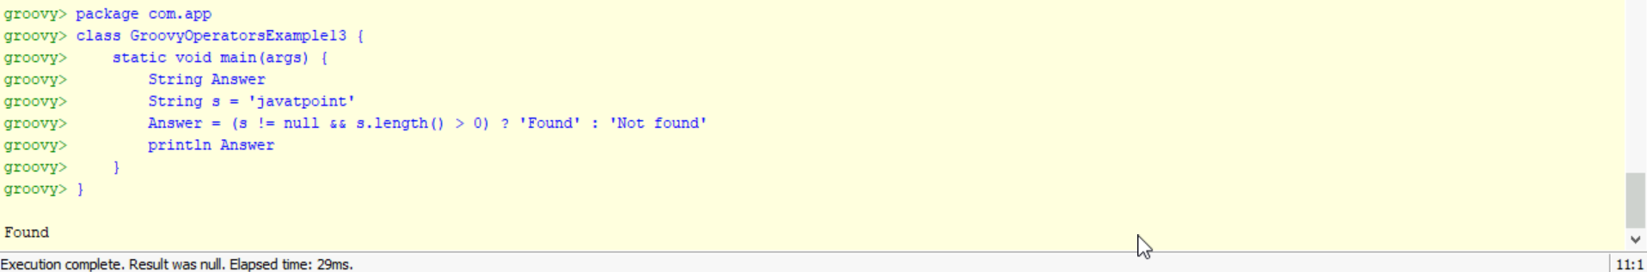

Example 14:

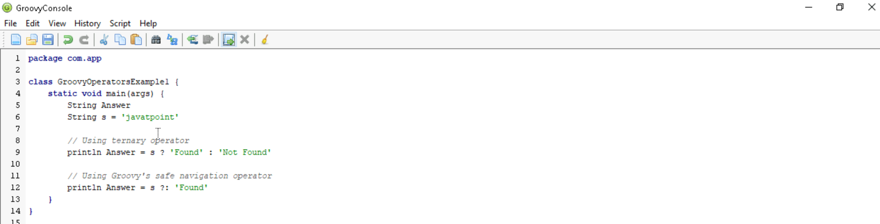

Output:

